# A*

<https://www.geeksforgeeks.org/a-search-algorithm/>

Pathfinding, divides the area into different nodes. Finds the fastest path towards the goal from the starting position based on the weight of the neighboring nodes.

# Flocking

<https://eater.net/boids>

<https://vanhunteradams.com/Pico/Animal_Movement/Boids-algorithm.html>

An algorithm used to simulate a flocking behavior, following three rules; separation, cohesion and alignment.

# Quad Tree

This divides the nodes relevant for the A* algorithm so they are easier to access.

Instead of looping through them all at runtime, the root node checks it’s 4 children and one of those checks it’s 4 children etc.

# Behavior Tree

<https://www.gamedeveloper.com/programming/behavior-trees-for-ai-how-they-work>

This is used instead of a finite state machine.

It works by traversing a root node down a tree to find leaves. It doesn’t traverse every node in the tree.

A node has the status of either running, success or failure. This determines the traversal.

## Sequence Nodes

These are composite nodes, meaning they have multiple children and they go through each child in a sequence.

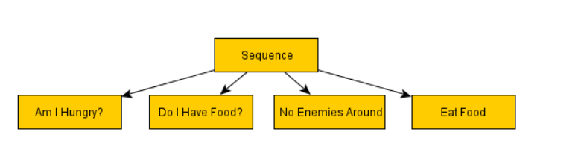

One of the nodes can be inverted with a decorator-node meaning only one child. This can work as a possible exit.

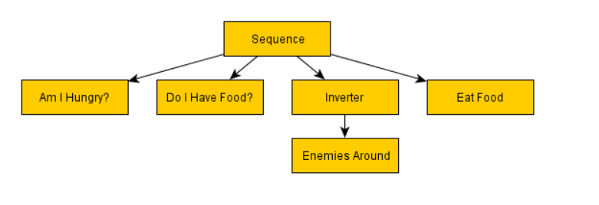

## Selector

This returns as soon as one child has succeeded.

